Chillout program guide

# **Setup:**

1. Open the "**Chillout Program Package**" folder
2. Install all the existing programs in the "**Setup**" folder
3. Create the path "**D:\Shalaby\Chillout\Chillout**" and move the following folders and files to that path:
   1. "**frontend**"
   2. "**backend**"
   3. "**Chillout.bat**"
   4. "**Chillout.ico**"
4. Create the path "**D:\Shalaby\Chillout**" and move the "**wildfly-18.0.0.Final**" folder to that path
5. If MongoDB was installed successfully, move the content of "Full database" folder to path "**C:\Program Files\MongoDB\Server\4.2\data**"
6. Move the "**Chillout**" (Shortcut) file to Desktop

# **Running:**

1. Start the program by clicking on the "**Chillout**" (Shortcut) in the Desktop
2. 2 servers will start running, minimize them and wait for the program to open completely

***Warning: the 2 servers must be running in order for the program to work correctly***

1. If there is at least 1 administrator in the database. The "**Login**" page will appear where you can insert your phone number and password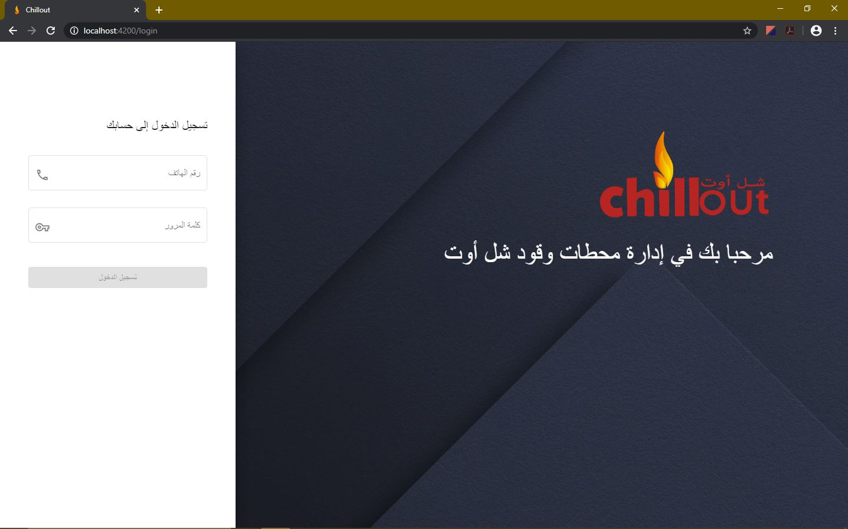, otherwise the "**Registration**" page will appear to create the first admin

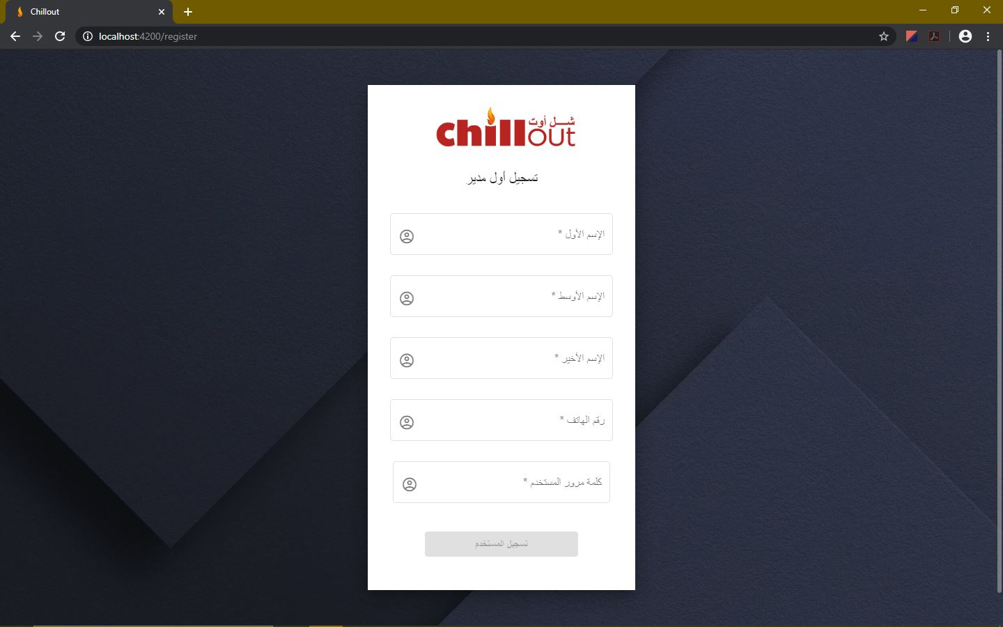

1. If the process is done successfully, you will be redirected to the "**Home**" page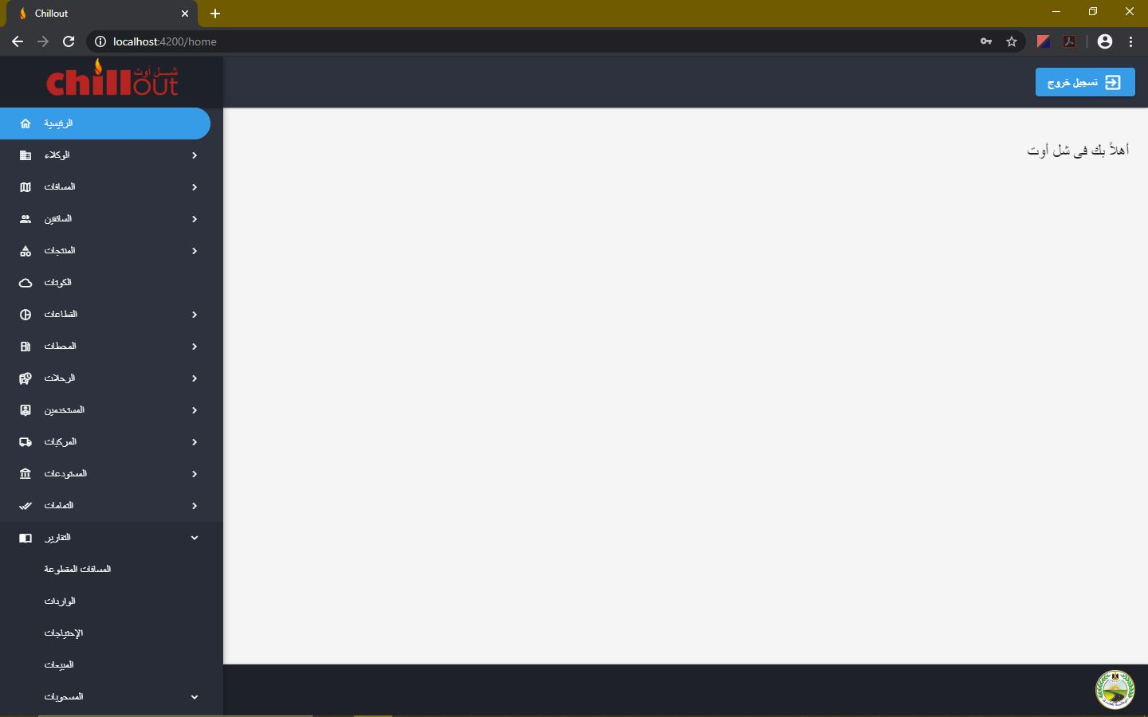
2. From here, you can navigate to other pages through the navigation bar on the left or log out from the "**Log out**" button

## **Agents:**

1. In the "**Create**" page, a new agent can be created by providing the required data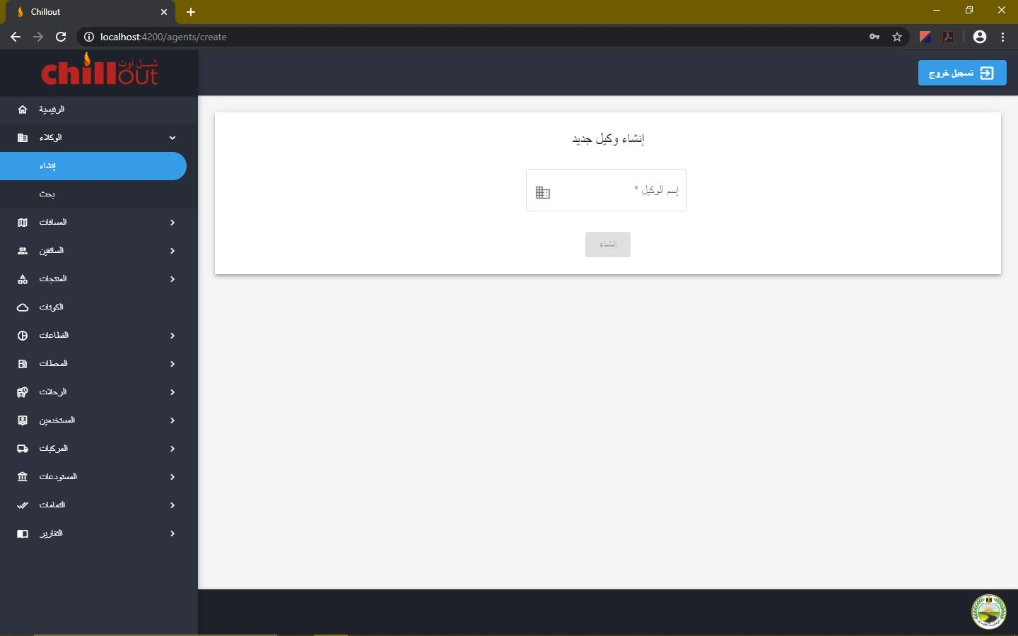
2. In the "**Search**" page, all the agents are listed. You can search for any agent in the search bar, browse through the table pages or change the number of items shown per page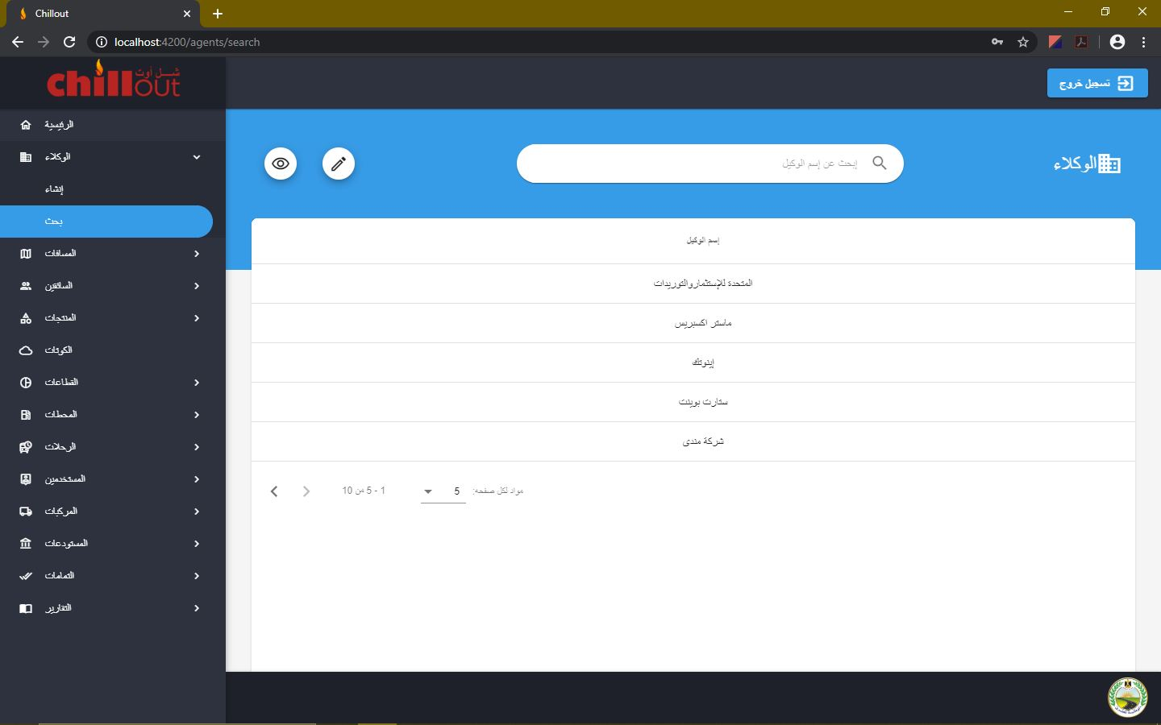
3. You can also hide or show any agent in the program by entering the Show/Hide mode from the eye like icon. Clicking on the icon next to the agent toggles between showing and hiding that item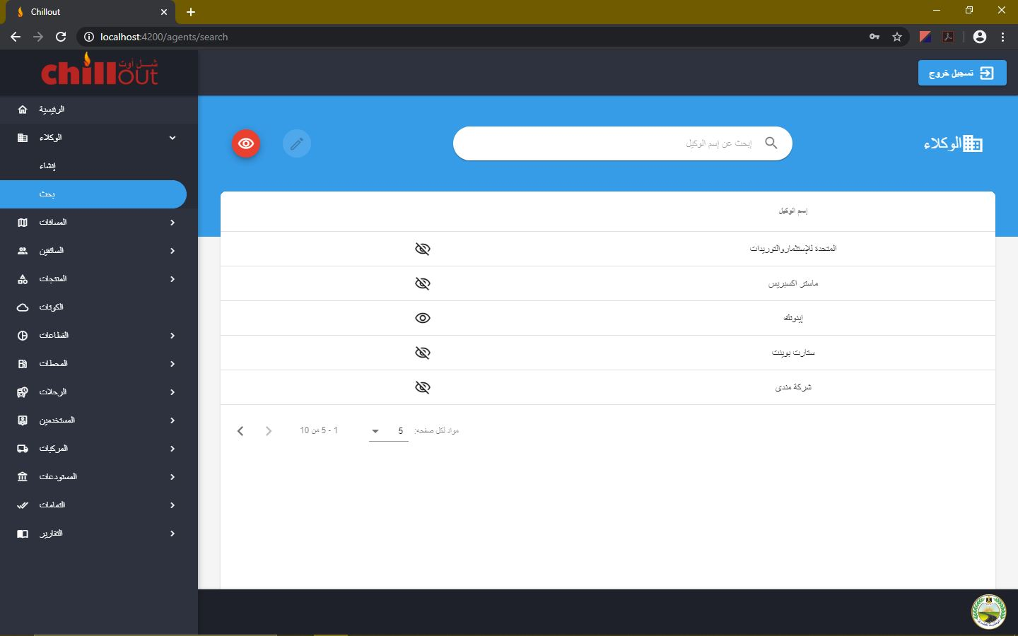

## **Distances:**

1. In the "**Create**" page, a new distance can be created by providing the required data

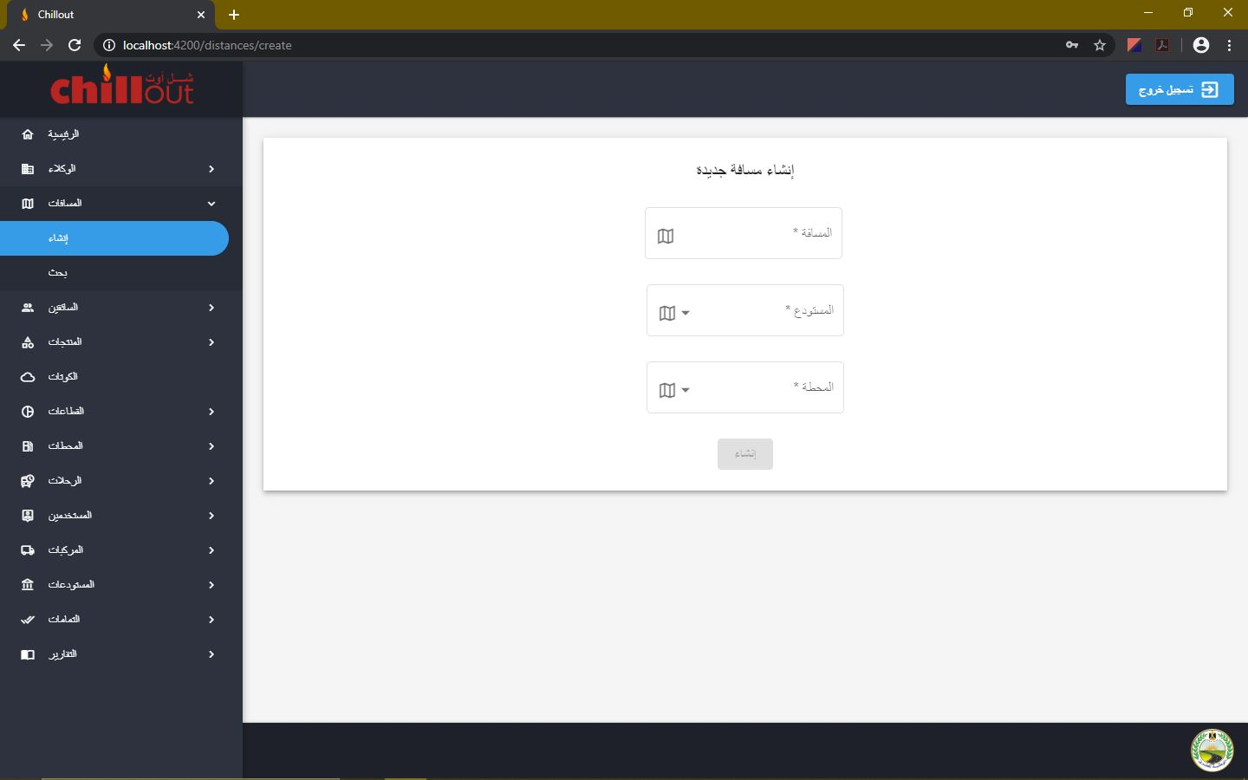

1. In the "**Search**" page, all the distances are listed. You can search for any distance in the search bar, browse through the table pages or change the number of items

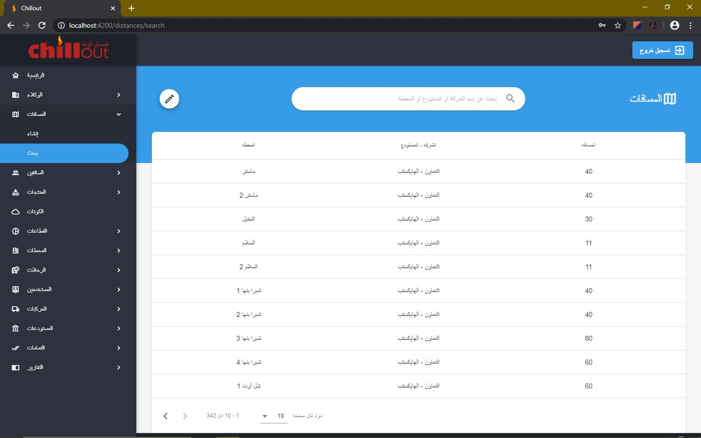

## **Drivers:**

1. In the "**Create**" page, a new driver can be created by providing the required data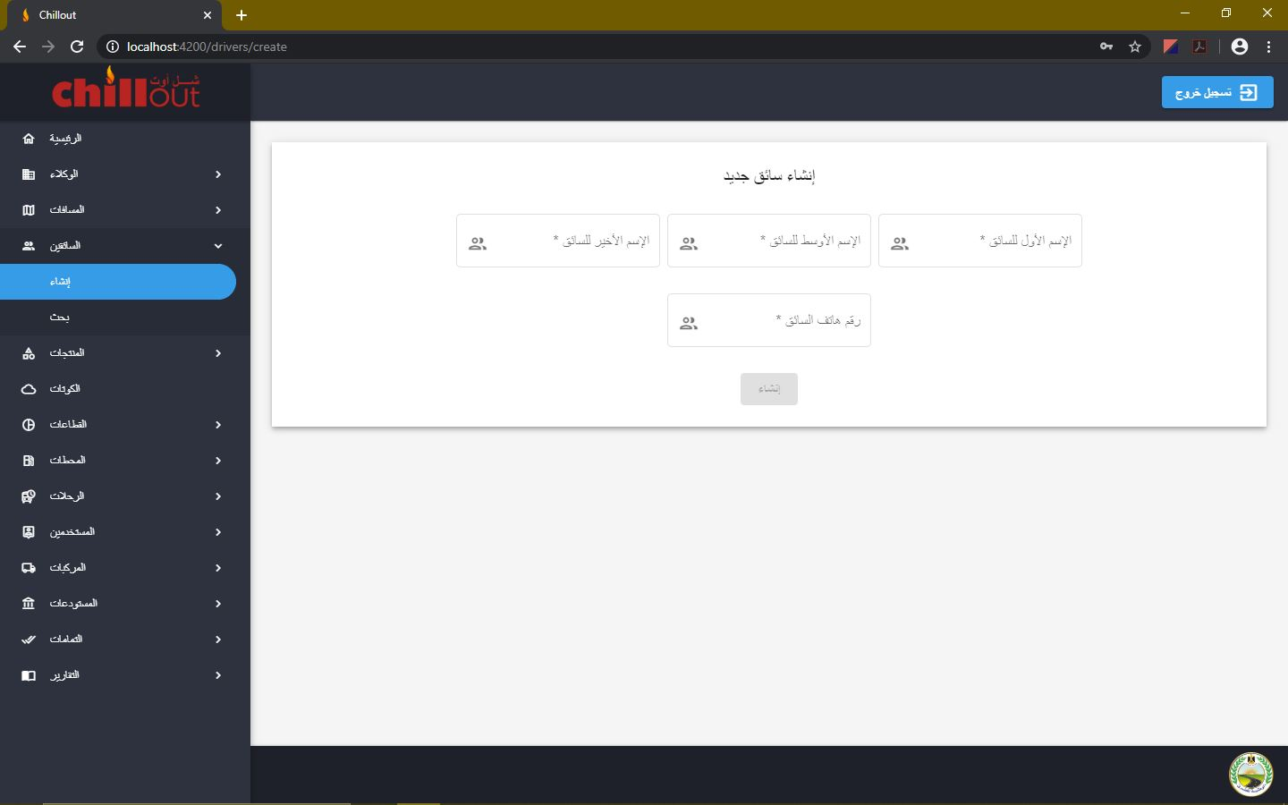
2. In the "**Search**" page, all the drivers are listed. You can search for any driver in the search bar, browse through the table pages or change the number of items shown per page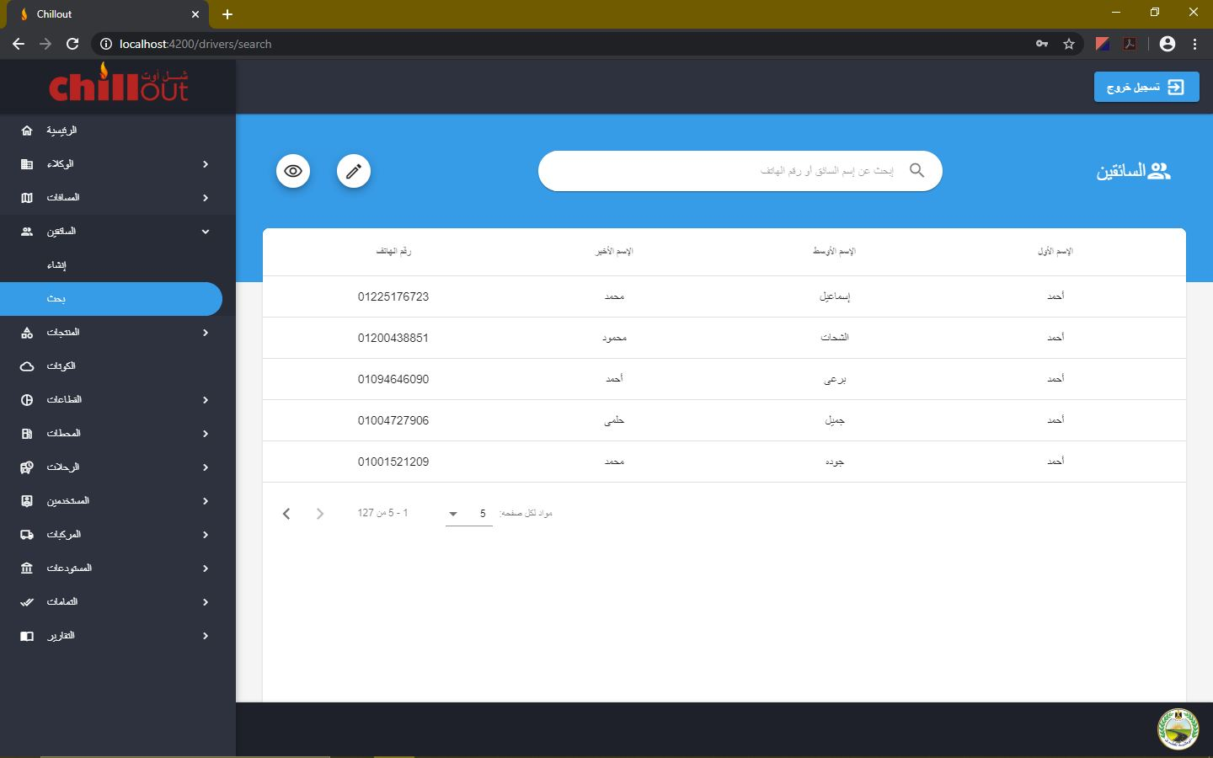

## **Products:**

1. In the "**Create**" page, a new product can be created by providing the required data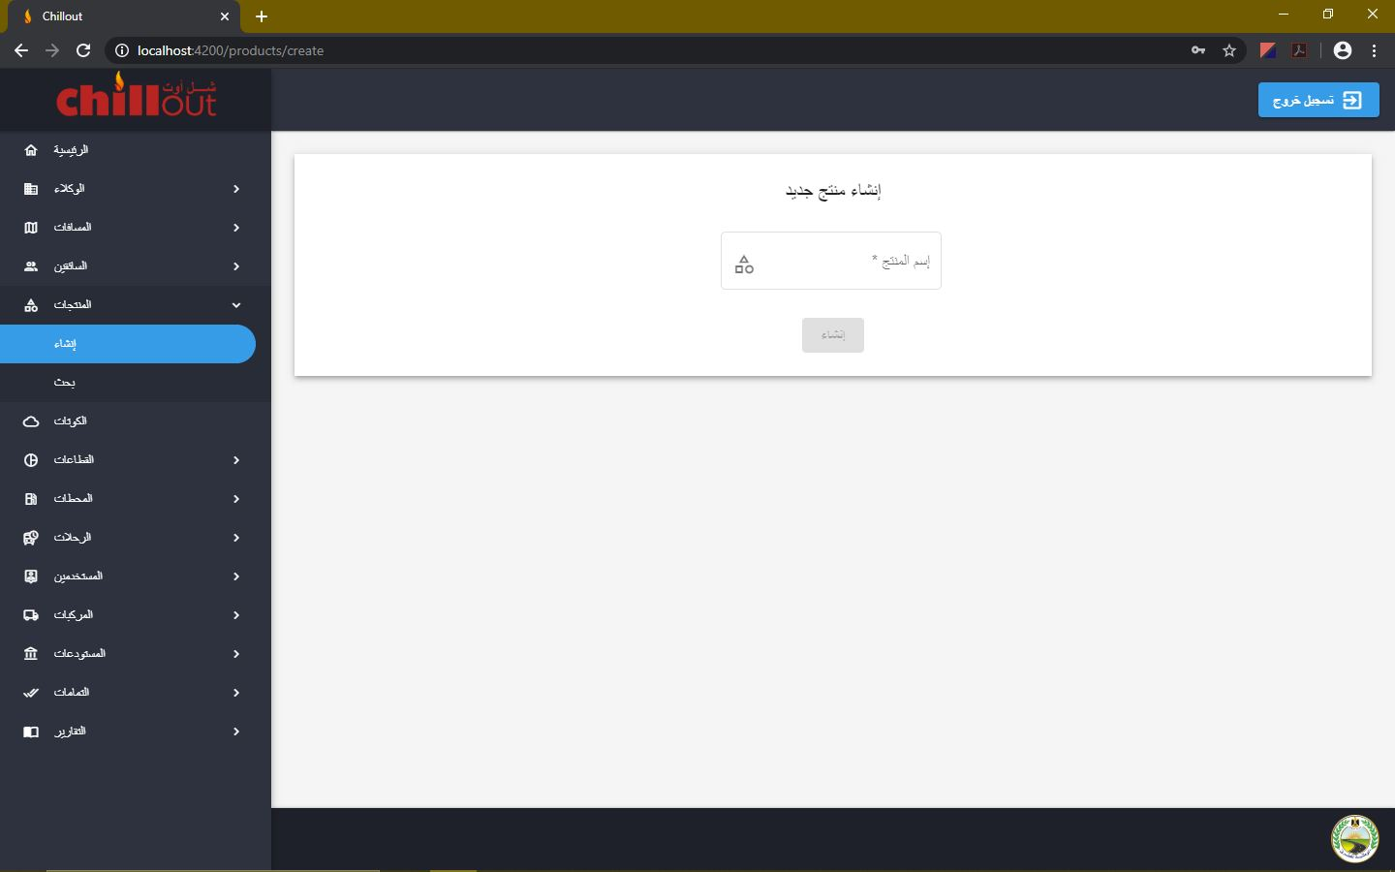
2. In the "**Search**" page, all the products are listed. You can search for any product in the search bar, browse through the table pages or change the number of items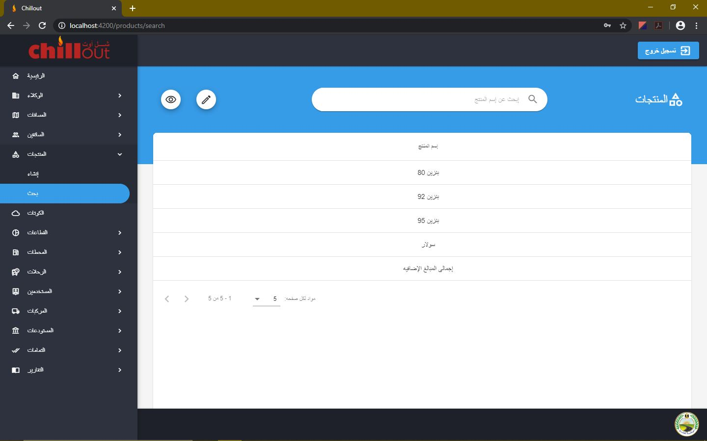

## **Quotas:**

1. Monthly quota is listed according to the date chosen from the date picker. You can view, edit, export any quota

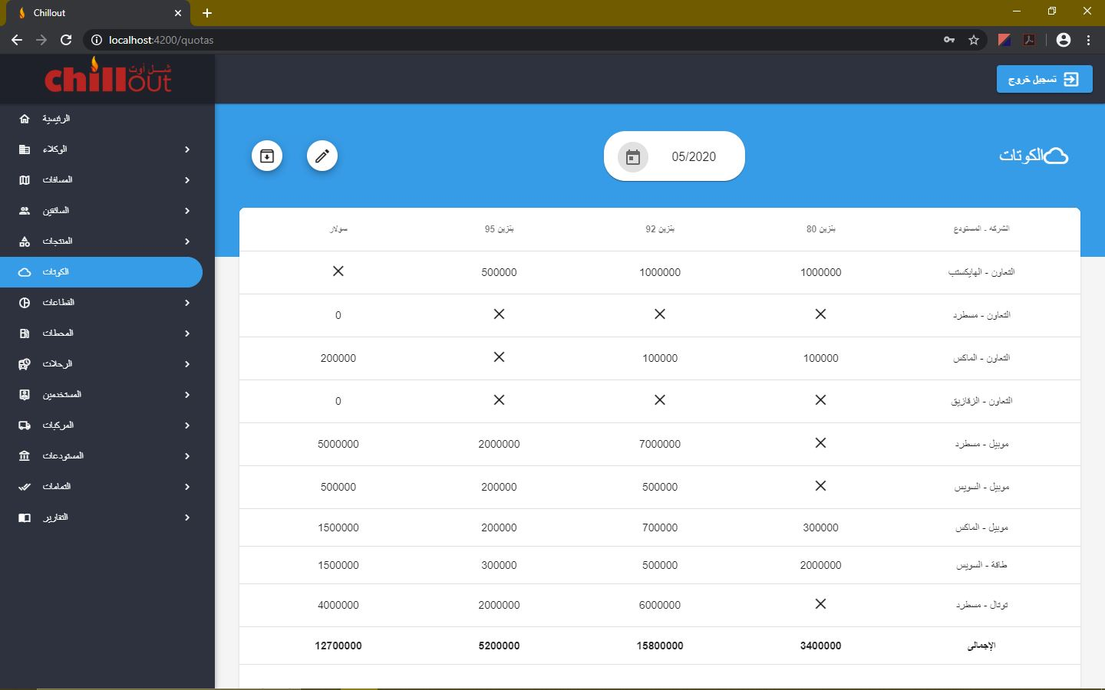

## **Sectors:**

1. In the "**Create**" page, a new sector can be created by providing the required data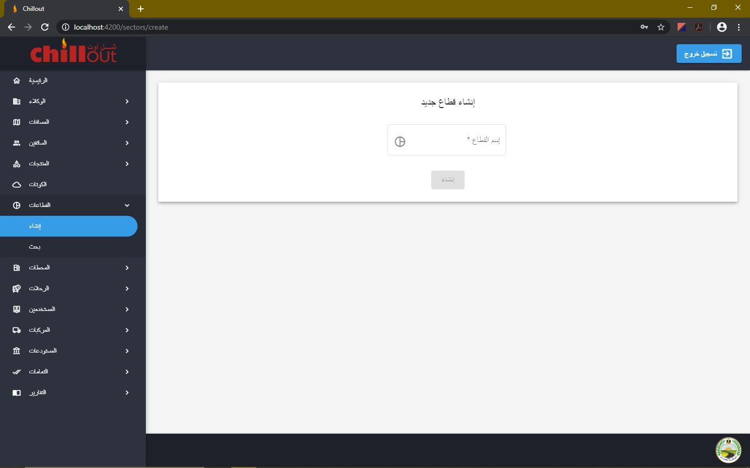
2. In the "**Search**" page, all the sectors are listed. You can search for any sector in the search bar, browse through the table pages or change the number of items shown per page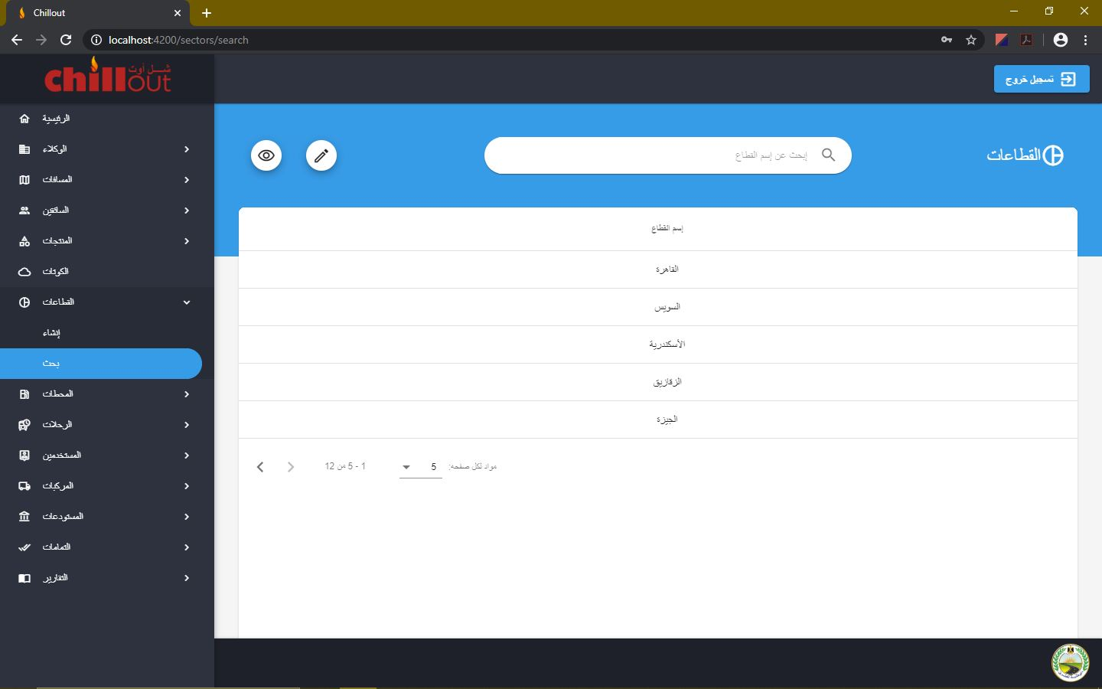

## **Stations:**

1. In the "**Create**" page, a new station can be created by providing the required data. If a new station is created, you have to go to that station page and add its tanks and products, and you have to go to the distances creation page and create a distance between it and every warehouse available. If the distance is not yet known initialize it by 0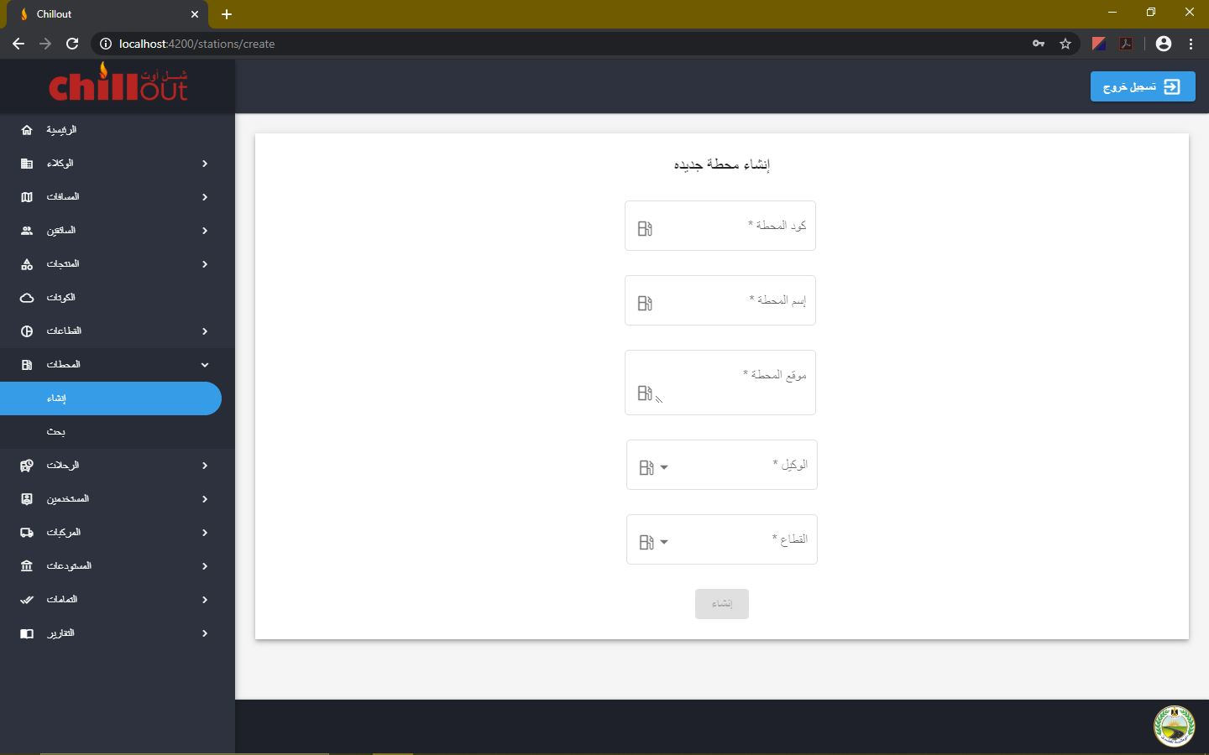
2. In the "**Search**" page, all the stations are listed. You can search for any station in the search bar, browse through the table pages or change the number of items shown per page. To access station details, click on it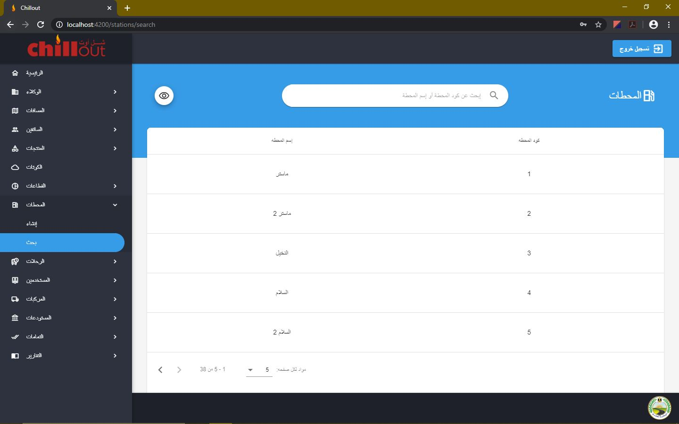
3. In the "**About**" page, all the details are shown, and you can also delete any product this station has. ***Warning: Deleting a product from a station should only be used if its product is not yet used anywhere in the program***

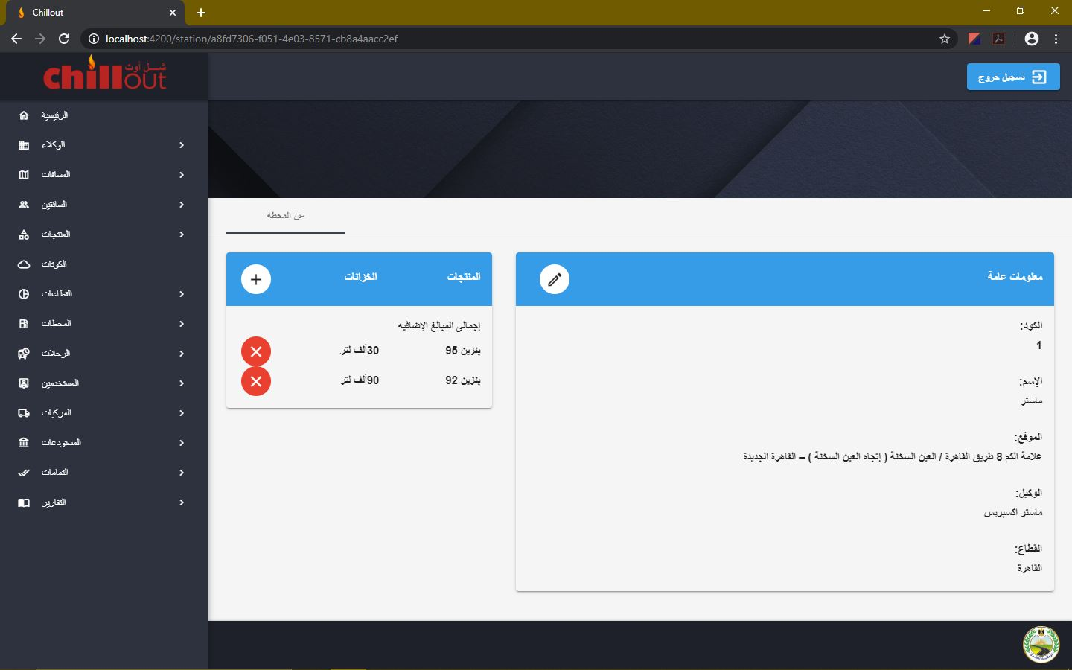

1. You can add a attach a product to the station by clicking on the add button and fill the required data

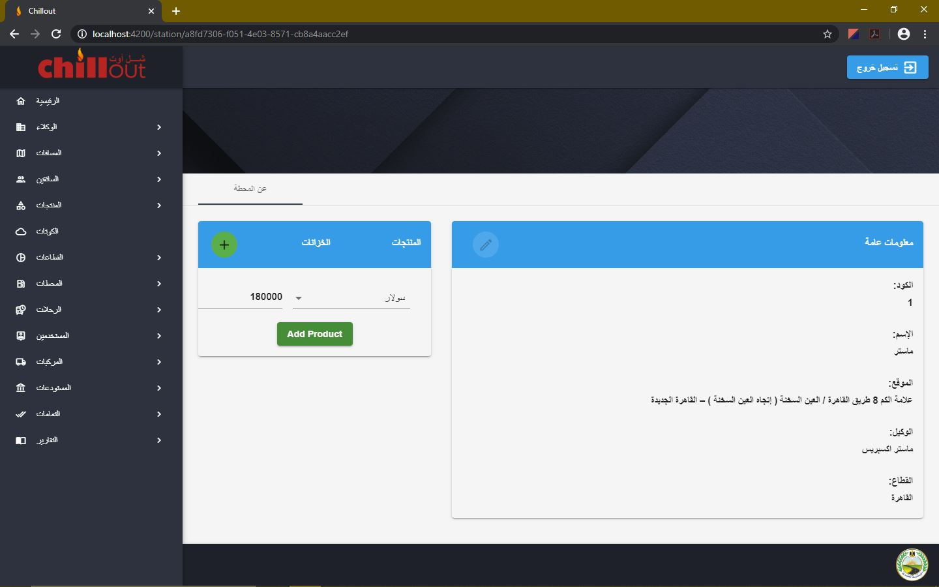

1. You can edit the existing data by clicking on the edit button, changing the data and clicking again on the edit button to save the changes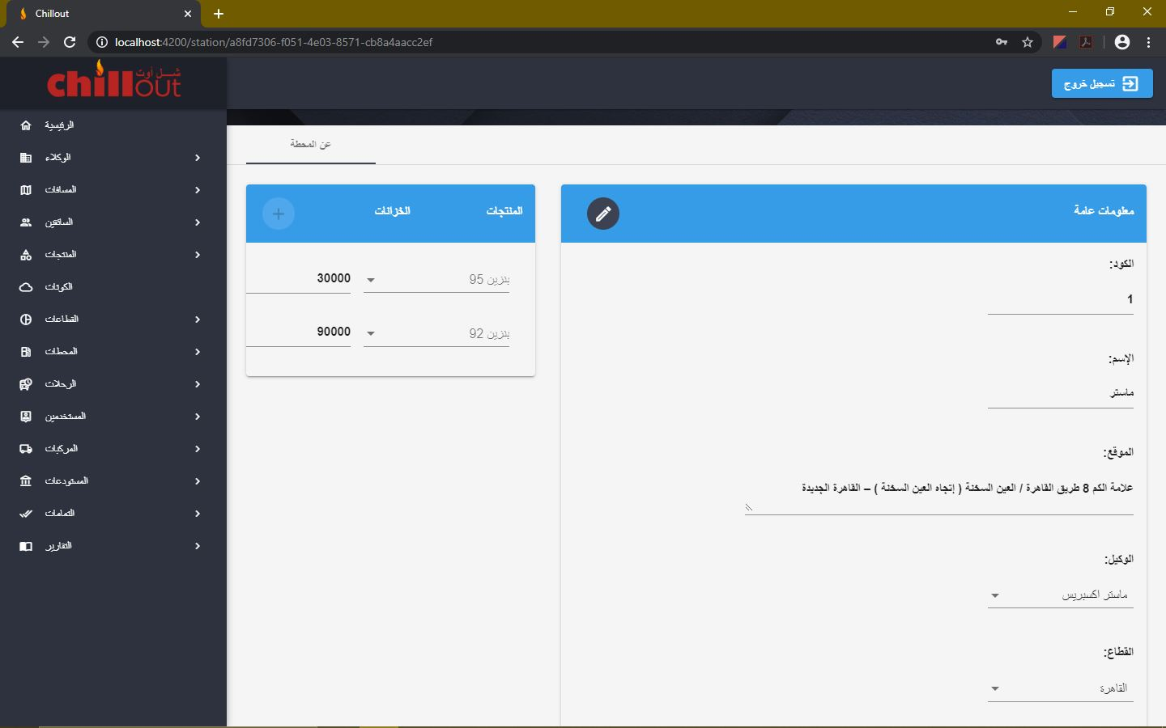

## **Trips:**

1. In the "**Create**" page, you need to choose the trip date from the date picker in order to start creating a new trip through several steps. You start by filling the required trip data. Note: If the step is not optional, then you can't proceed to the next step until you finish filling the data of the current step

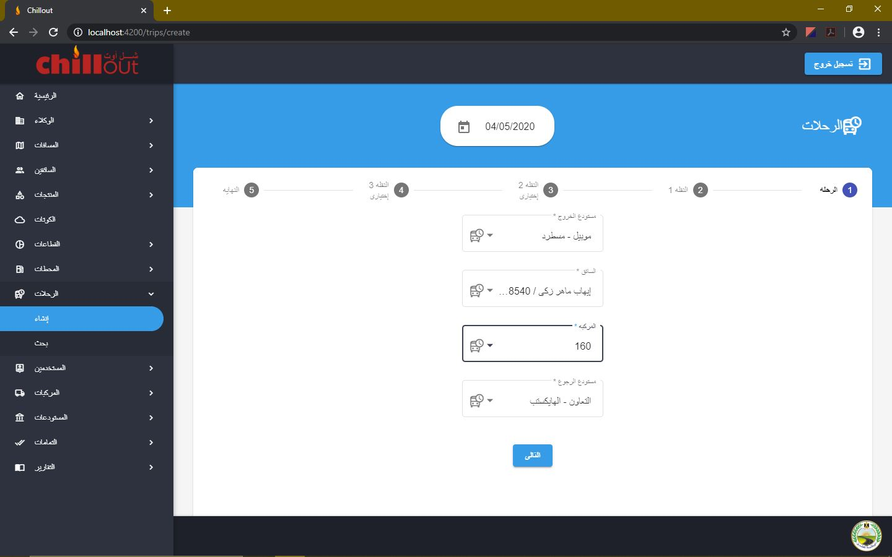

1. Then the first transfer required data is filled. Note this is not an optional step

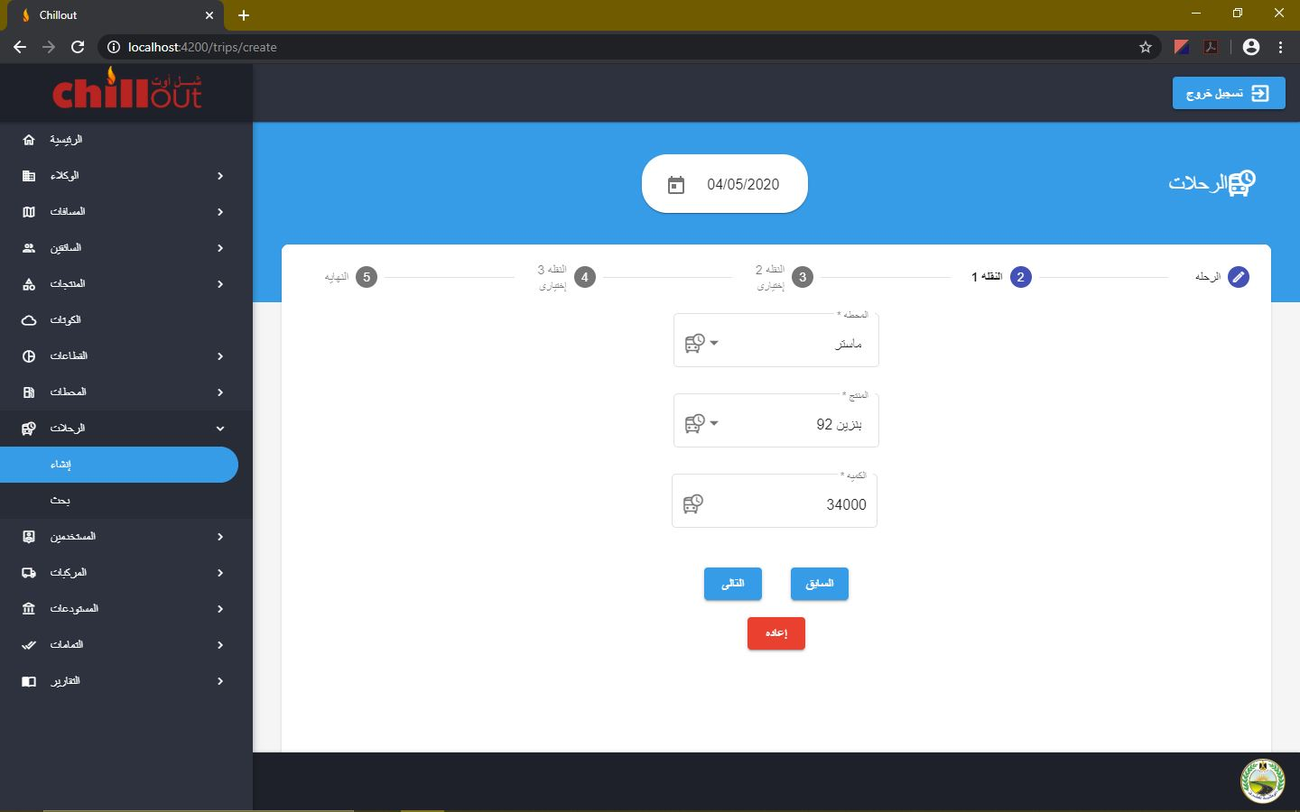

1. The second and third transfer are optional. In case you entered some data in this step by mistake and can't proceed to the next step, you can click on the reset button to clear the false data and change the step to optional again

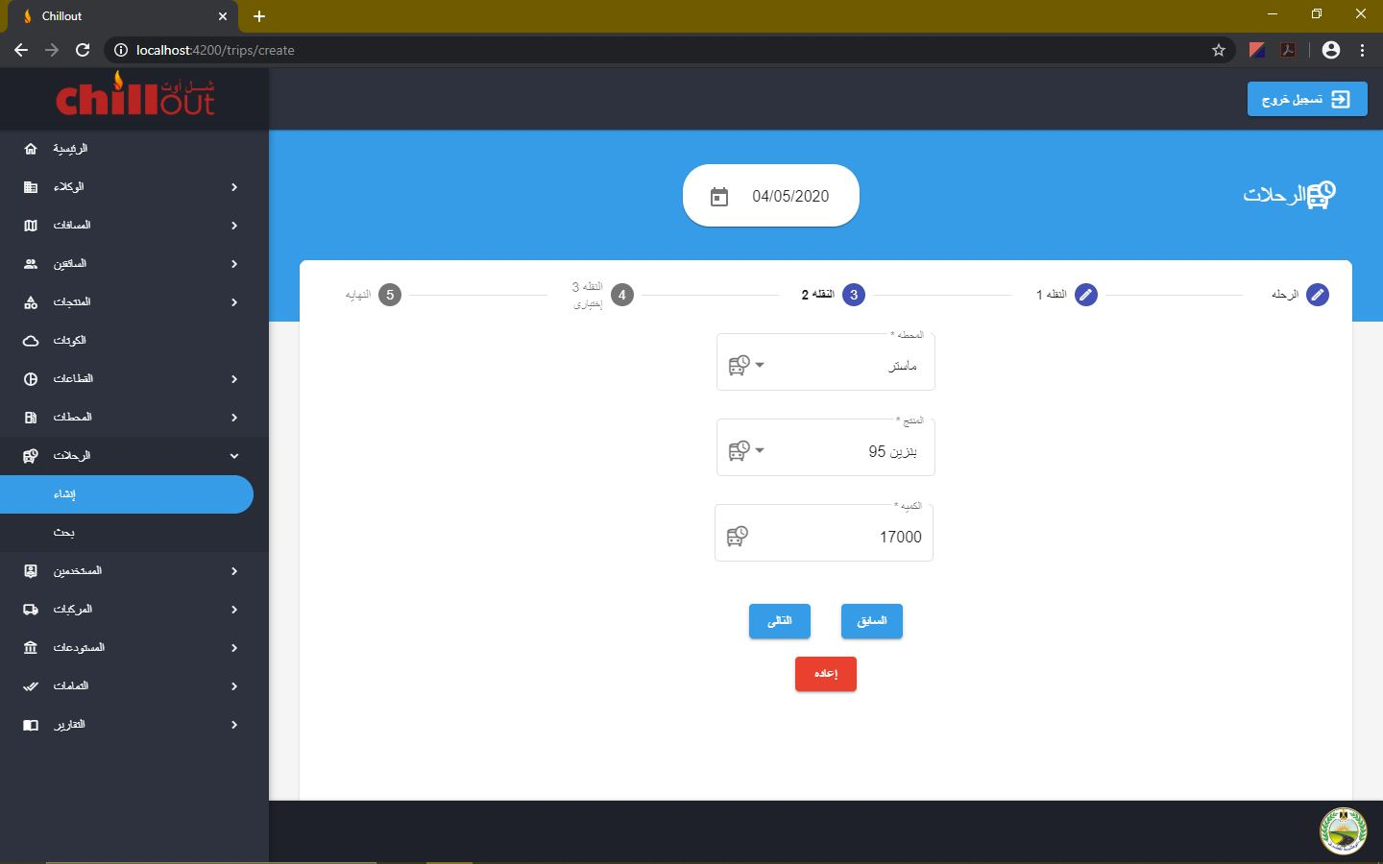

1. Before you click on the create trip button, you can jump to any step by clicking the step name, check the trip date and change any data. Clicking on the create trip button will create the trip and reset all steps directing you to the first step leaving the trip date as it is. 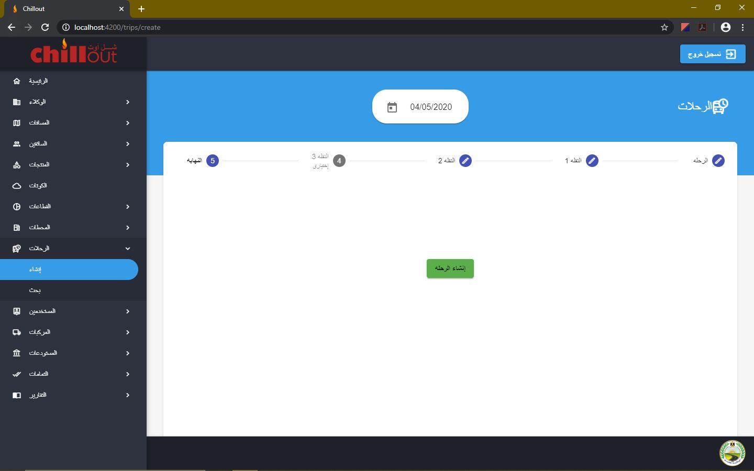
2. In the "**Search**" page, all the trips created in the selected date are listed. You can search for the trips of a certain vehicle in that date

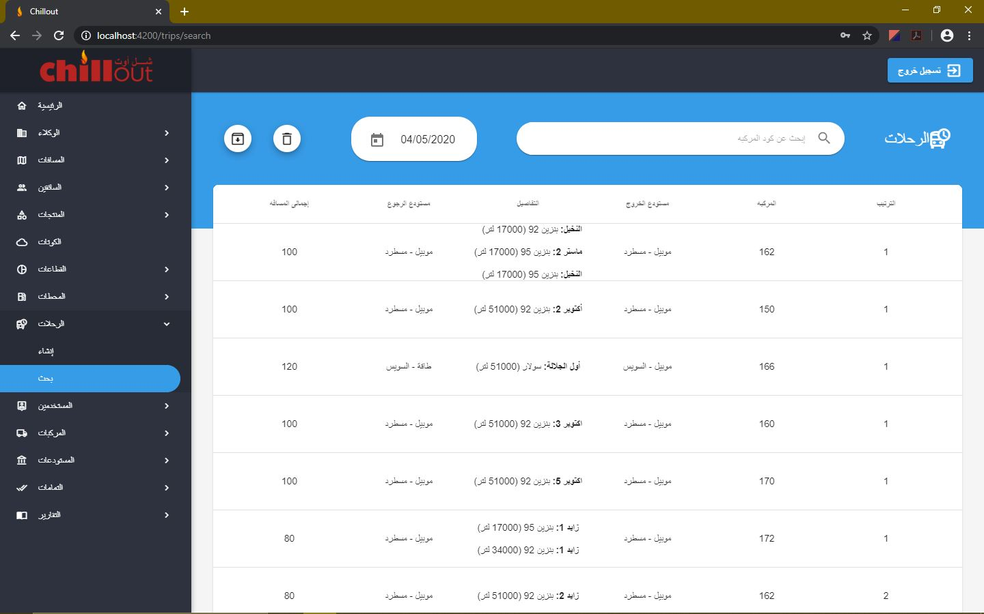

1. You can delete a trip by entering the delete mode from the bin like button. Clicking on the icon next to the trip deletes that item

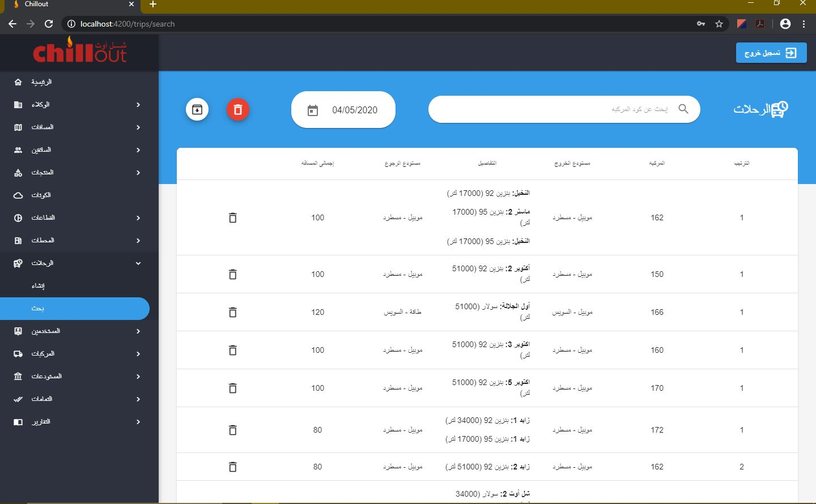

## **Users:**

1. In the "**Create**" page, a new user can be created by providing the required data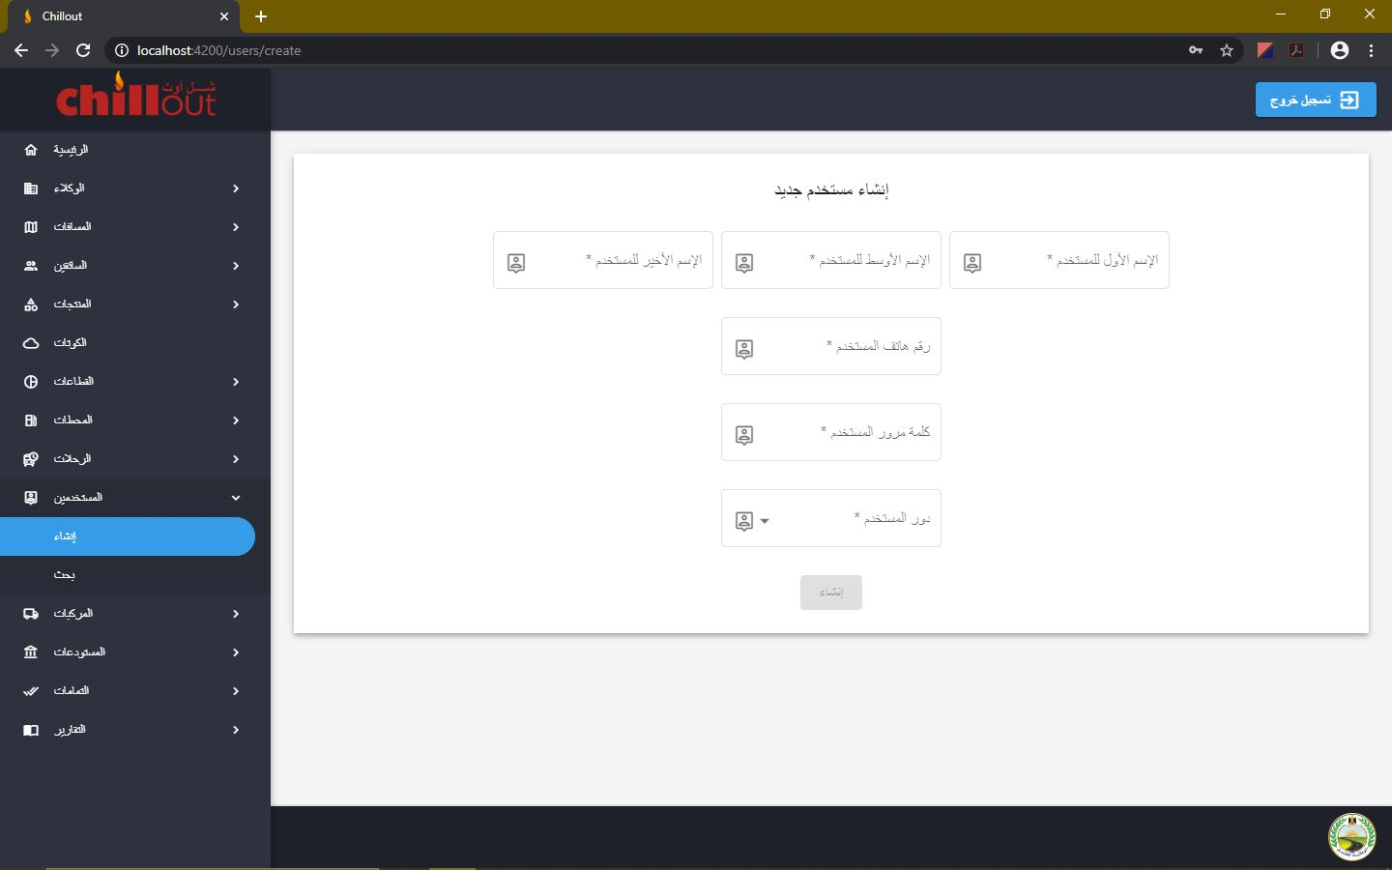
2. In the "**Search**" page, all the users are listed. You can search for any user in the search bar, browse through the table pages or change the number of items shown per page 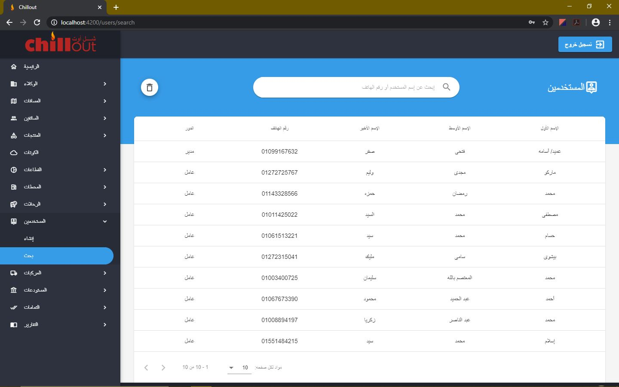

## **Vehicles:**

1. In the "**Create**" page, a new vehicle can be created by providing the required data. Note: plate letters have to be written without spaces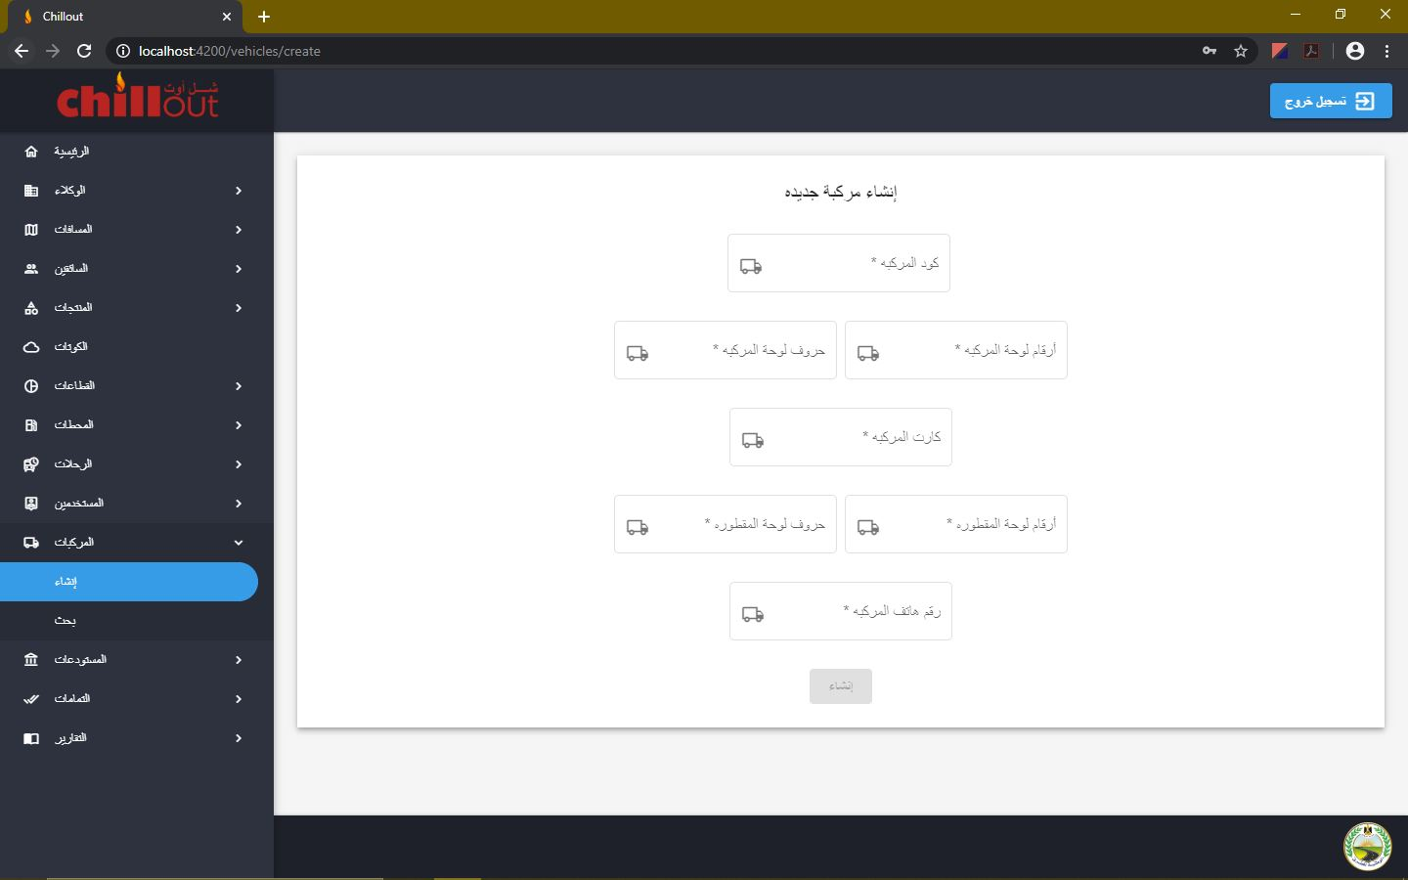
2. In the "**Search**" page, all the vehicles are listed. You can search for any vehicle in the search bar, browse through the table pages or change the number of items shown per page 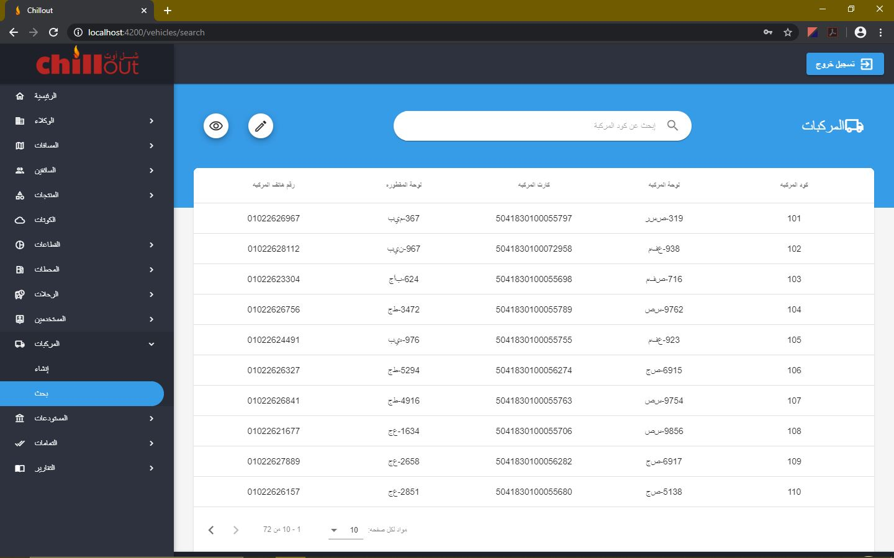
3. You can edit the existing data by clicking on the edit button. Pressing any key updates the changed field immediately.

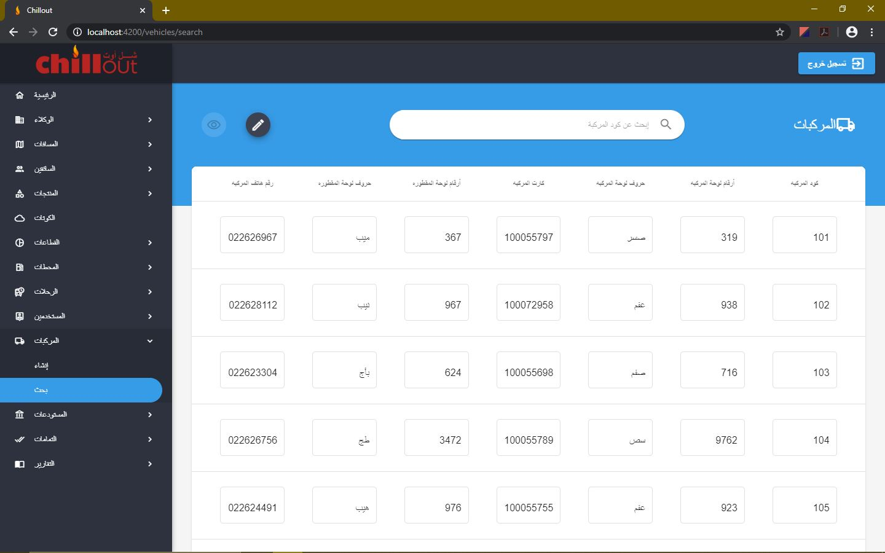

## **Warehouses:**

1. In the "**Create**" page, a new warehouse can be created by providing the required data. If a new warehouse is created, you have to go to that station page and add its tanks and products, and you have to go to the distances creation page and create a distance between it and every station available. If the distance is not yet known initialize it by 0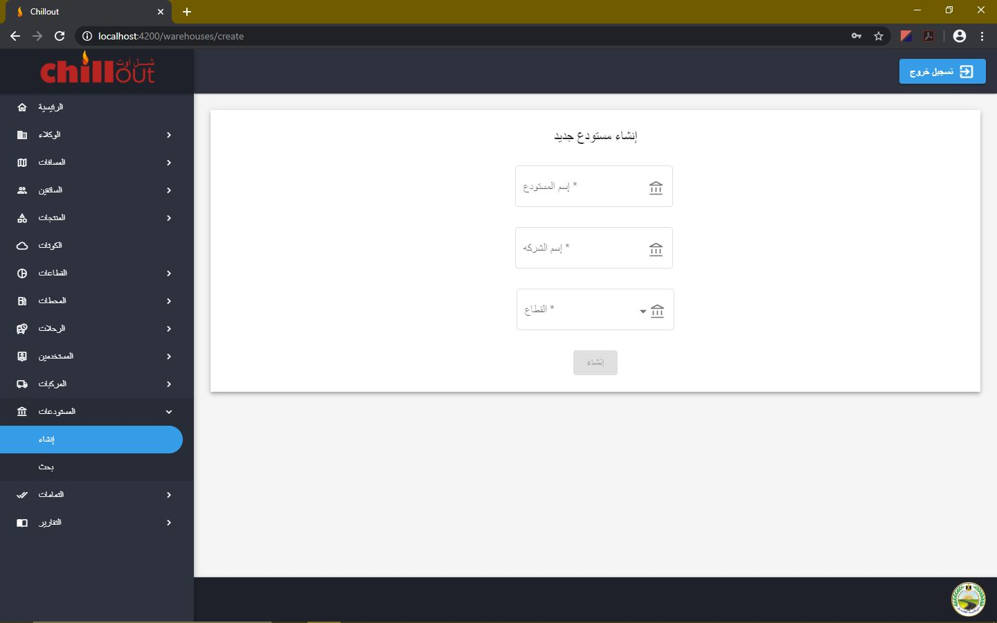
2. In the "**Search**" page, all the warehouses are listed. You can search for any warehouse in the search bar, browse through the table pages or change the number of items shown per page. To access warehouse details, click on it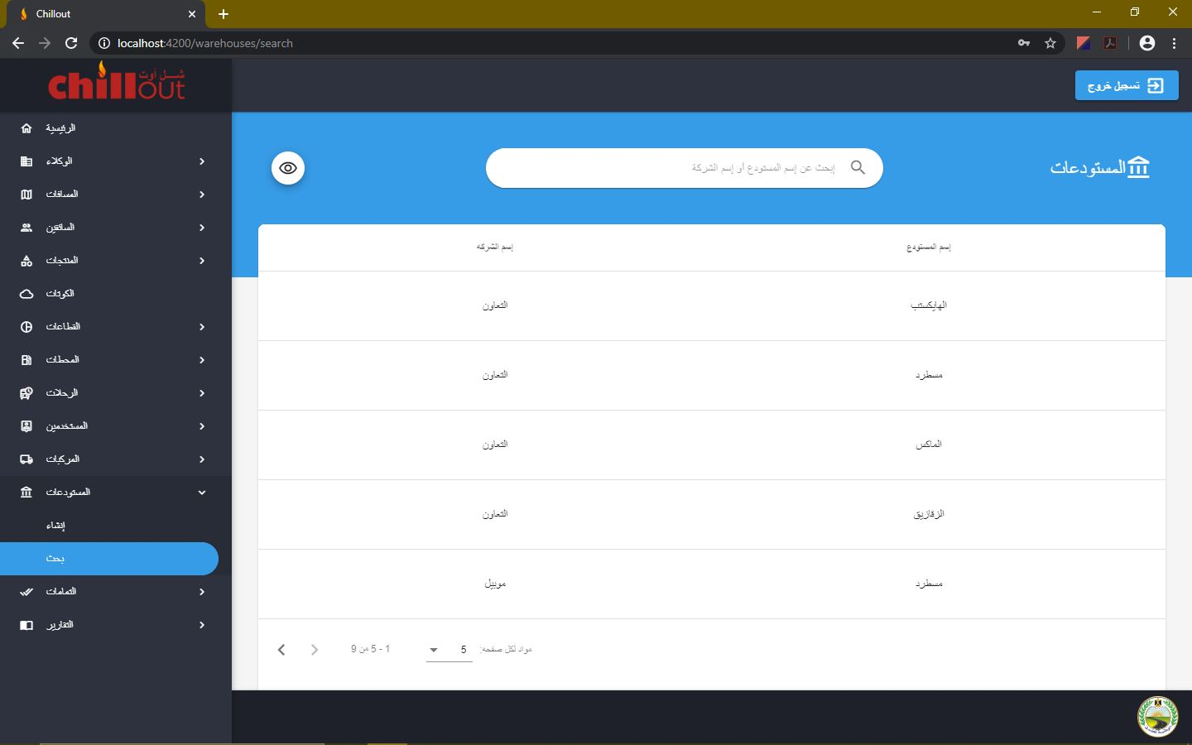
3. In the "**About**" page, all the details are shown, and you can also delete any product this warehouse has. ***Warning: Deleting a product from a warehouse should only be used if its product is not yet used anywhere in the program***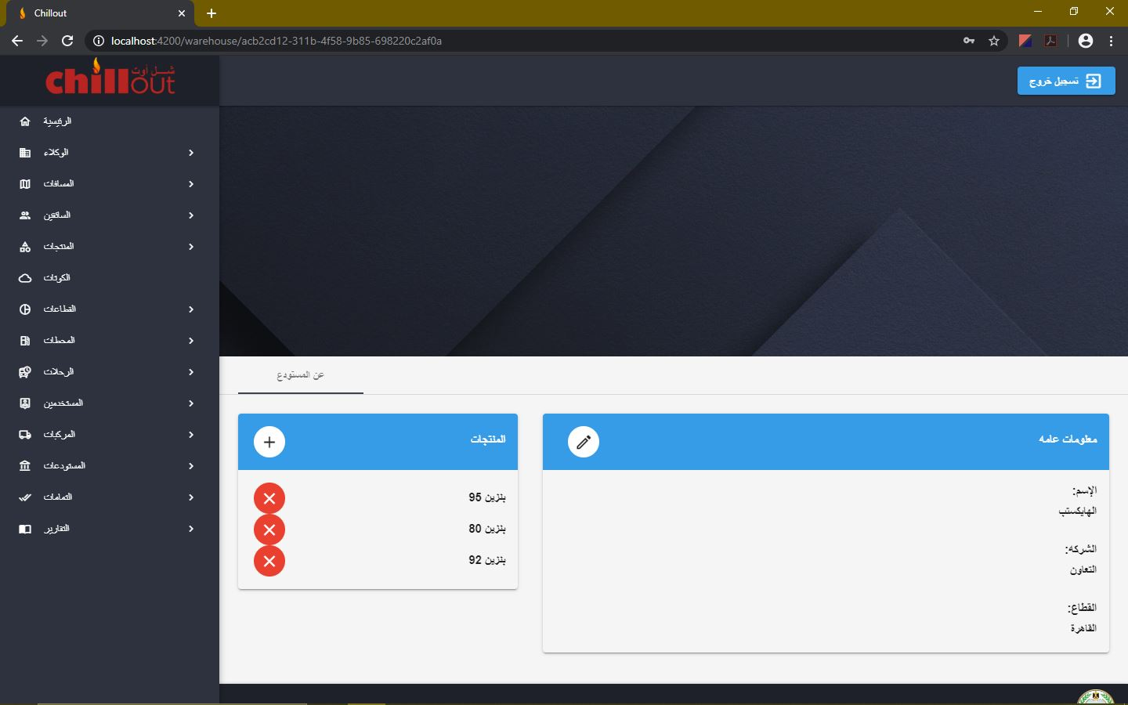
4. You can add a attach a product to the warehouse by clicking on the add button and fill the required data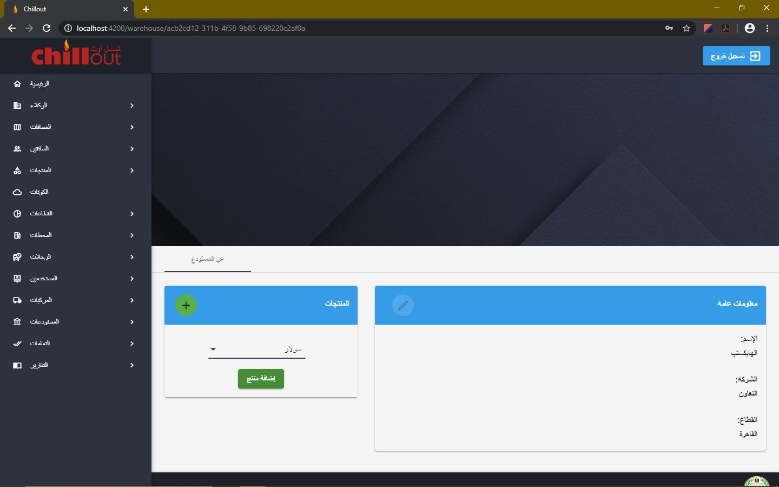
5. You can edit the existing data by clicking on the edit button, changing the data and clicking again on the edit button to save the changes

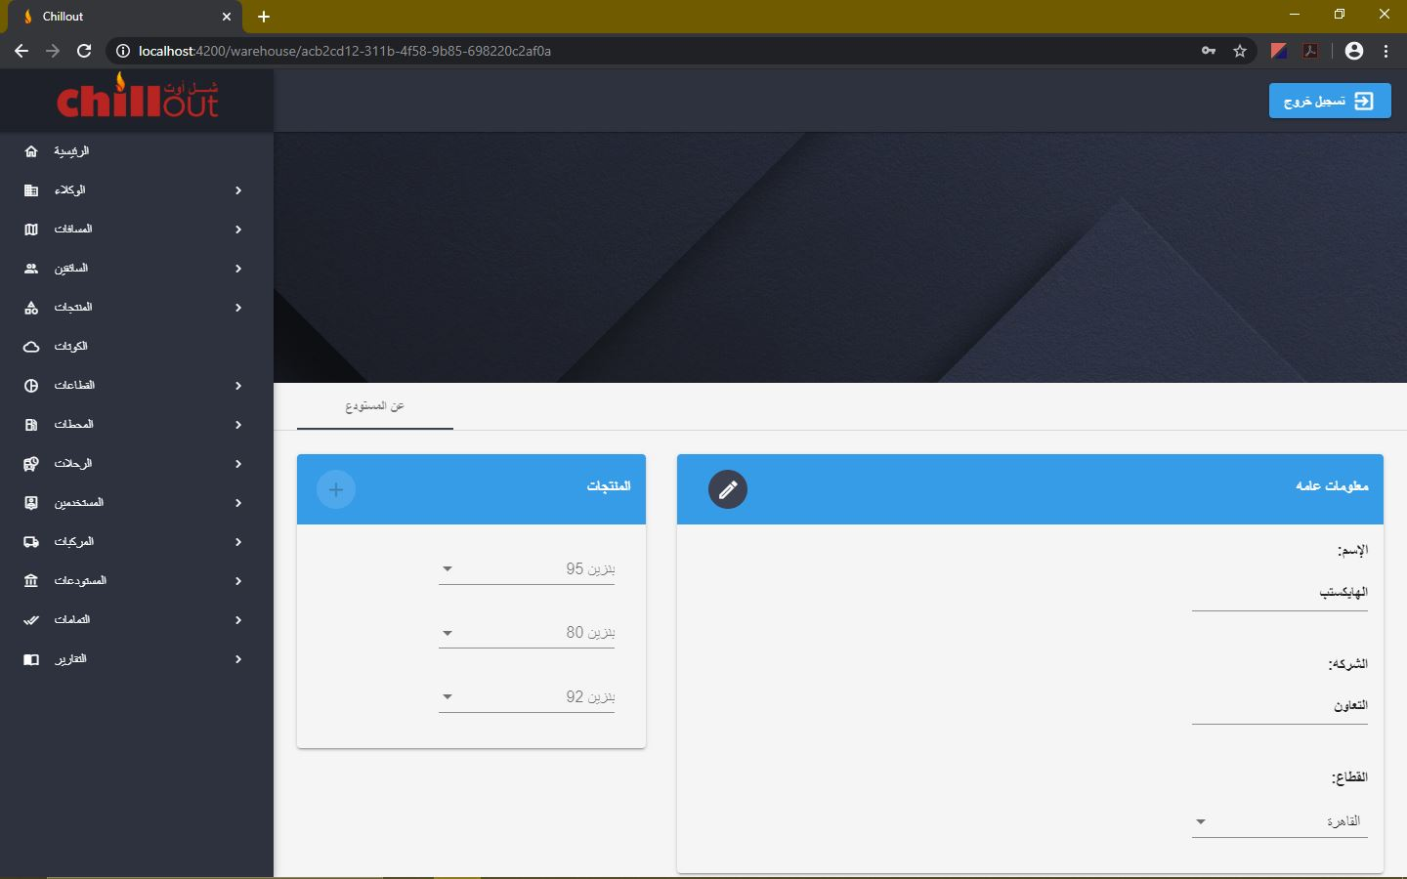

## **Acknowledgements:**

1. In the "**Sales**" page, all stations are listed with the unavailable products closed and can be searched for. The available products' sales can be edited by choosing the correct date and opening the edit mode

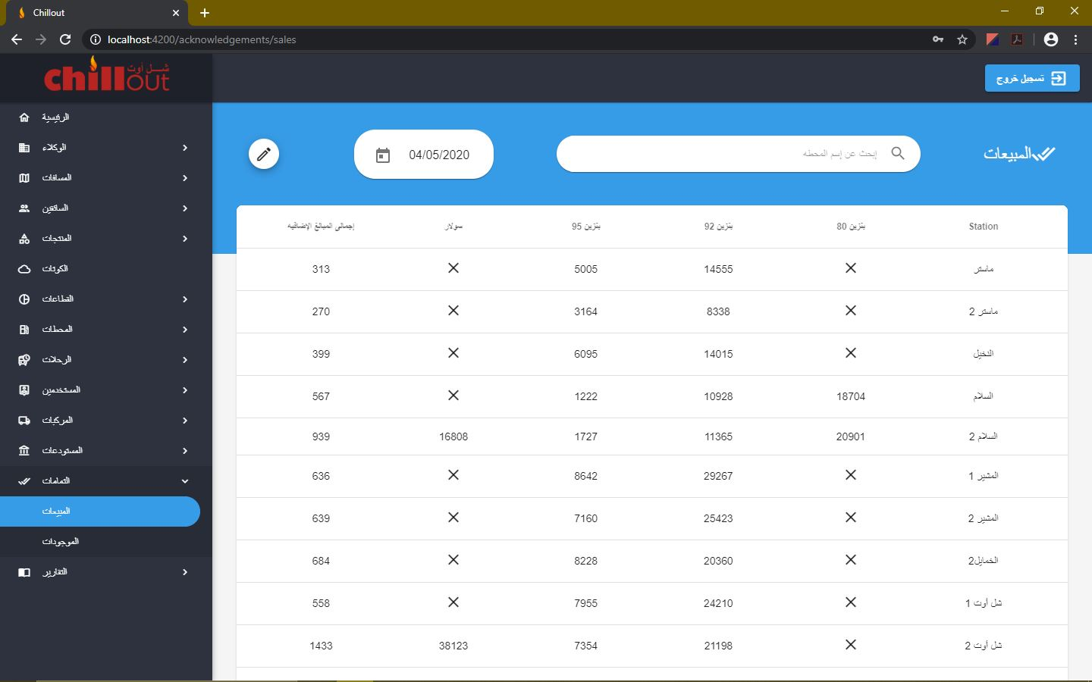

1. In the "**Existings**" page, all stations are listed with the unavailable products closed and can be searched for. The available products' existings can be edited by choosing

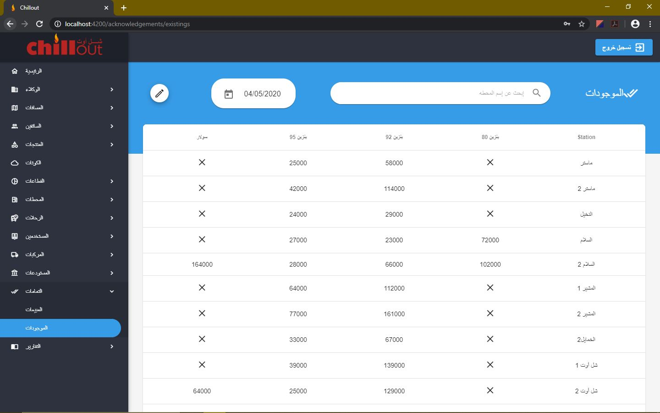

## **Reports:**

1. In the "**Distances Covered**" report, all days of the chosen month from the date picker are displayed showing the distance covered each day and the trips' count. Note: Table can be exported to excel file through the export button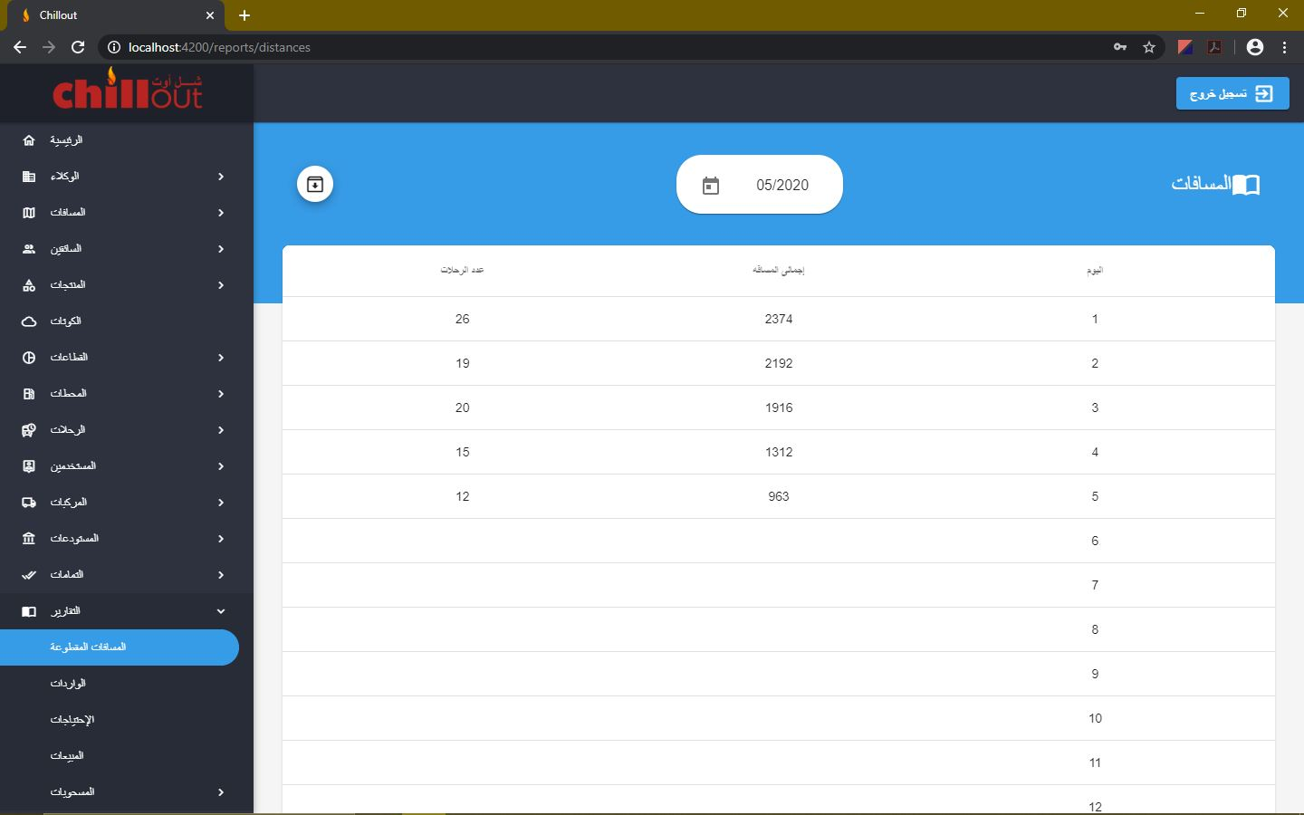
2. In the "**Imports**" report, all stations are displayed showing the imported amount from each product through the period between the start date and the end date and its sum. Selecting the start date automatically changes the end date to be equal to it to know the data of that specific date. While changing the end date doesn't change the start date to know the data between the two dates 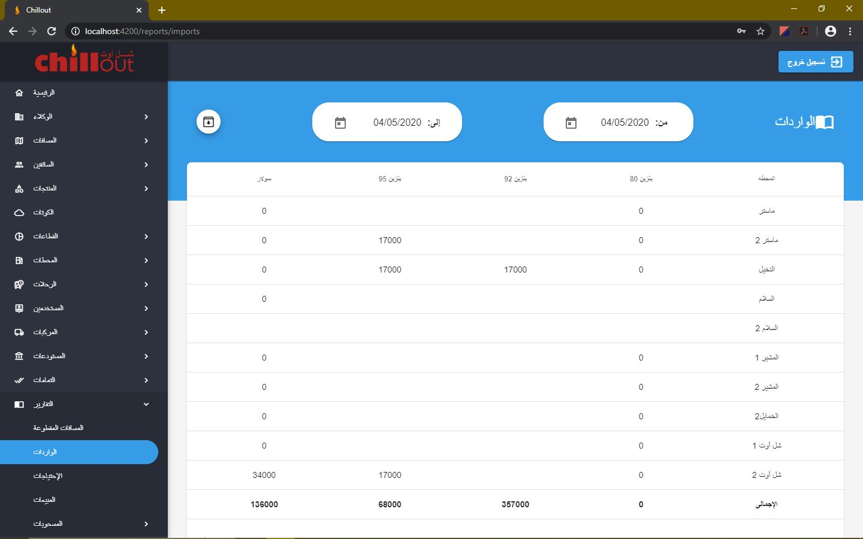
3. In the "**Needs**" report, all stations are displayed showing the needed amount from each product at that date and the full tank volume 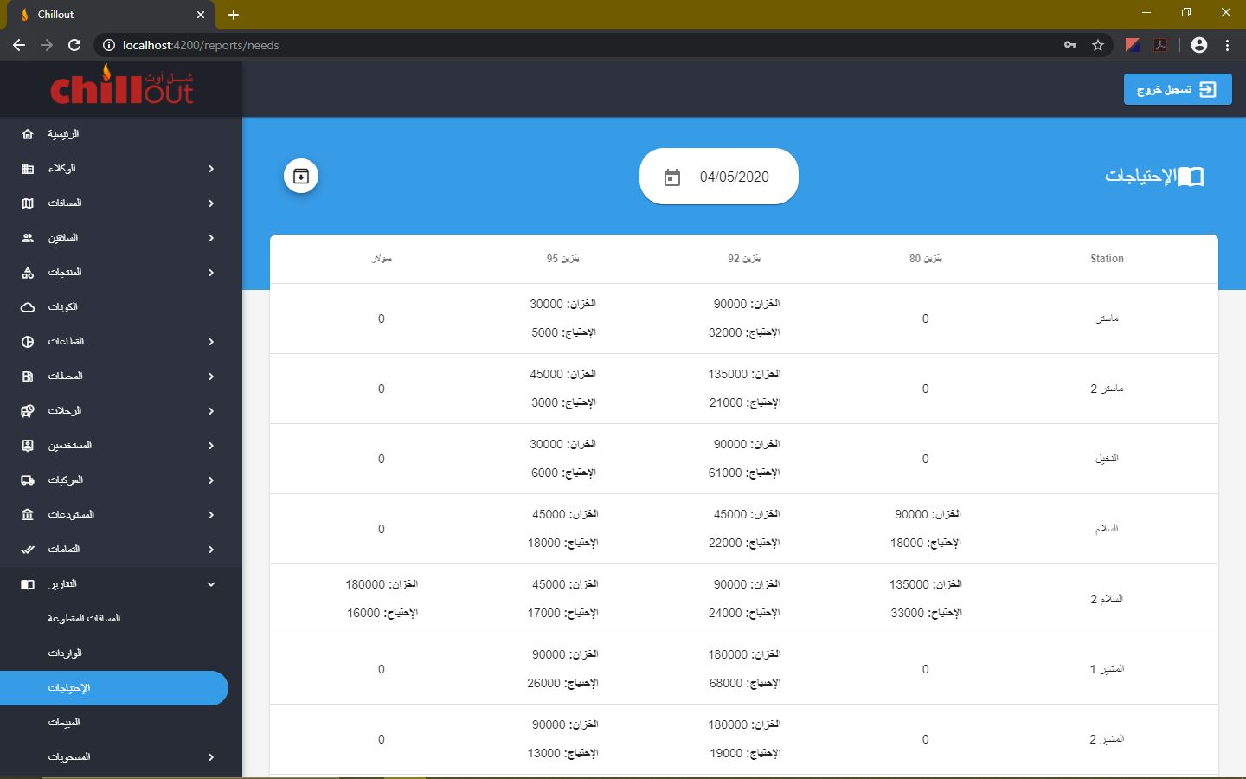
4. In the "**Sales**" report, all stations are displayed showing the sale amount from each product through the period between the start date and the end date and its sum. Selecting the start date automatically changes the end date to be equal to it to know the data of that specific date. While changing the end date doesn't change the start date to know the data between the two dates 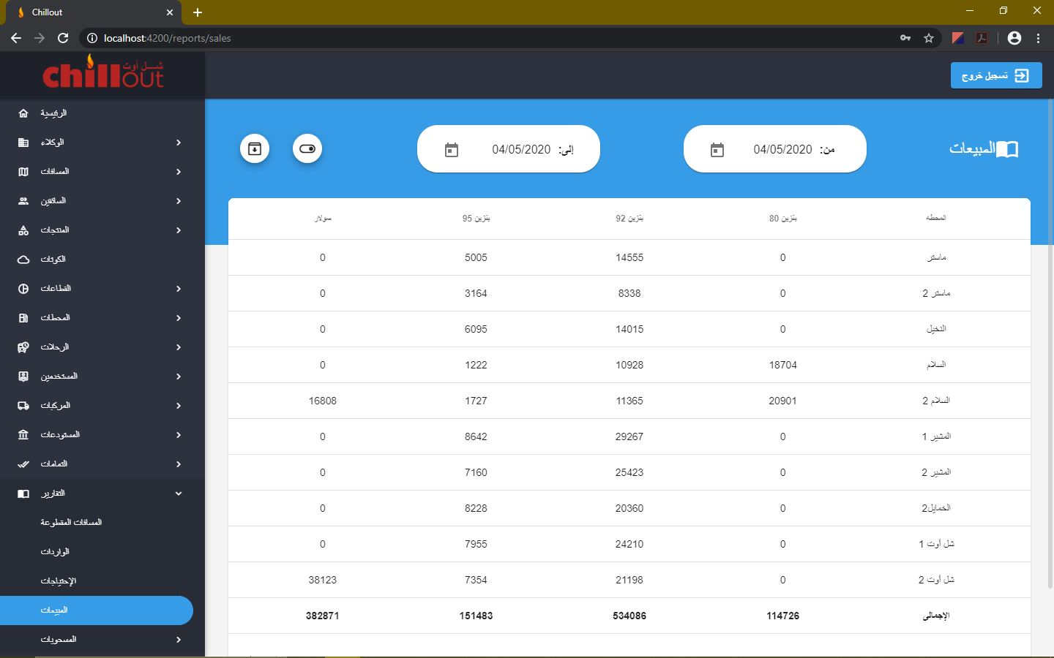
5. In the "**Sales**" report, all stations are displayed showing the sale amount from each product through the period between the start date and the end date and its average. Selecting the start date automatically changes the end date to be equal to it to know the data of that specific date. While changing the end date doesn't change the start date to know the data between the two dates 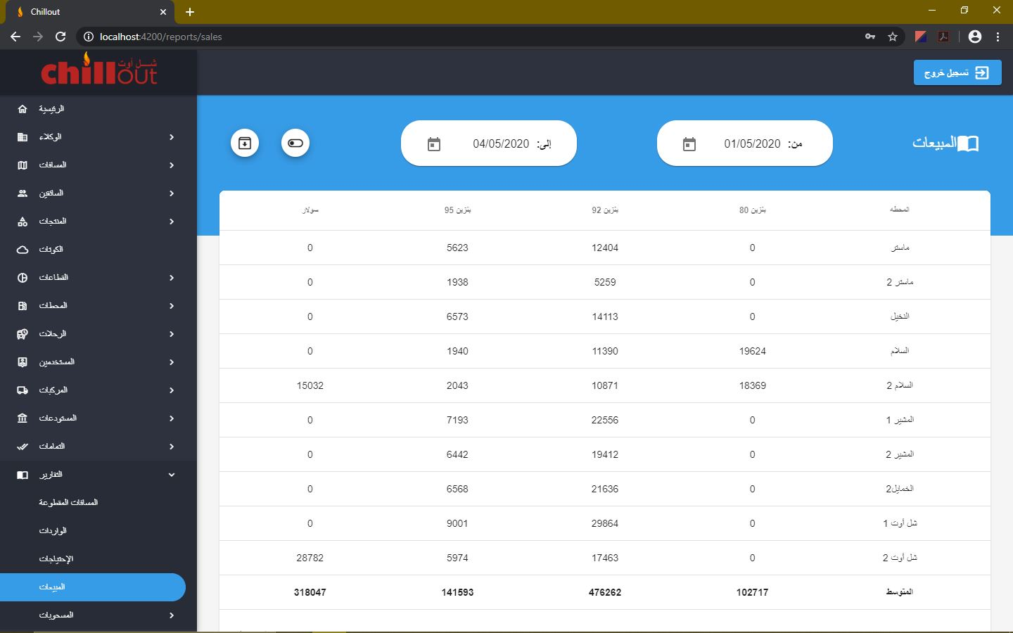
6. In the "**Companies Withdrawal**" report, all companies are displayed showing the exported amount from each product through the period between the start date and the end date. Selecting the start date automatically changes the end date to be equal to it to know the data of that specific date. While changing the end date doesn't change the start date to know the data between the two dates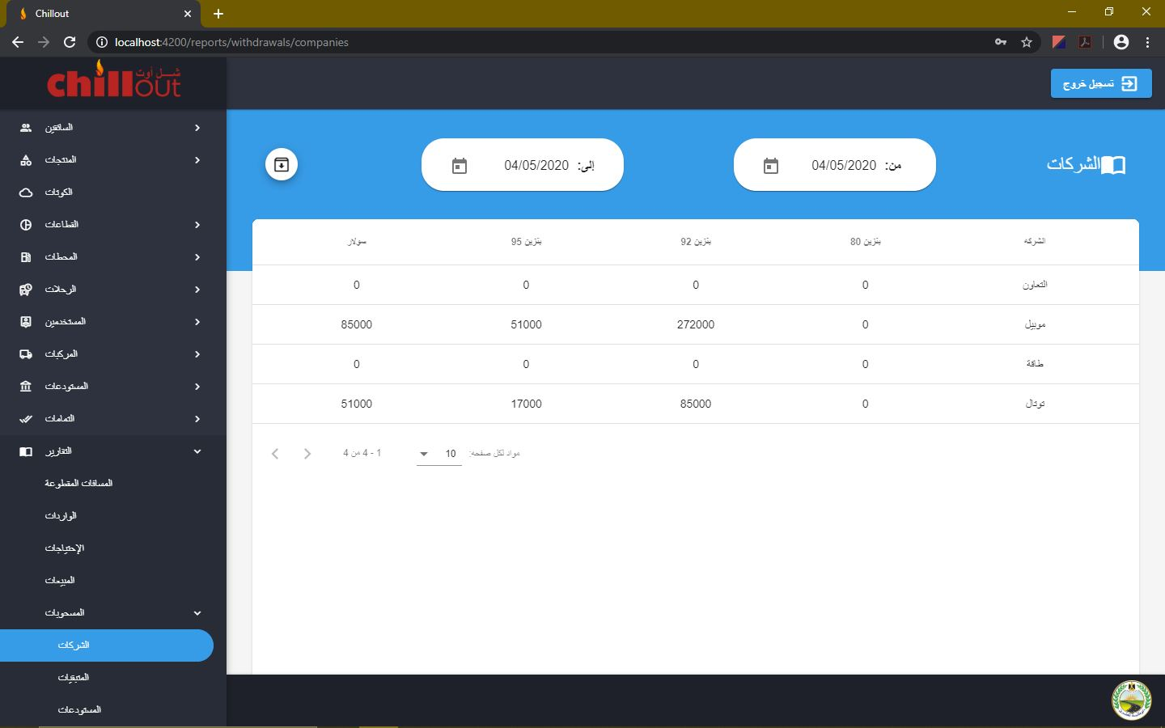
7. In the "**Remainings Withdrawal**" report, all warehouses are displayed showing the remaining amount from each product in the quota of the same month through the period between the start date and the end date and its sum. Selecting the start date automatically changes the end date to be equal to it to know the data of that specific date. While changing the end date doesn't change the start date to know the data between the two dates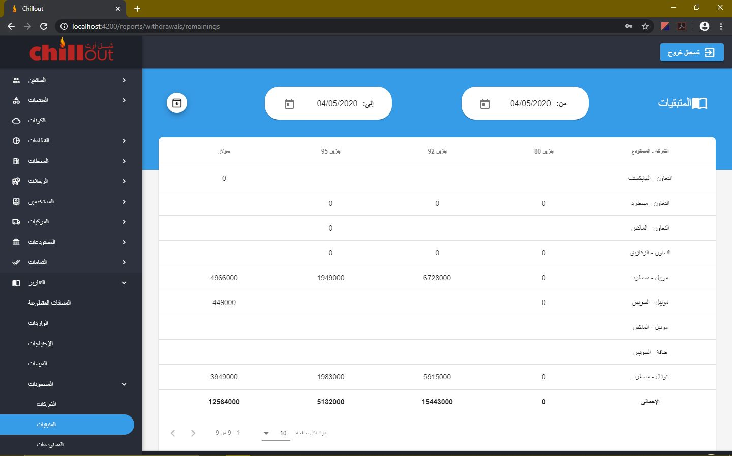
8. In the "**Warehouses Withdrawal**" report, all warehouses are displayed showing the exported amount from each product through the period between the start date and the end date and its sum. Selecting the start date automatically changes the end date to be equal to it to know the data of that specific date. While changing the end date doesn't change the start date to know the data between the two dates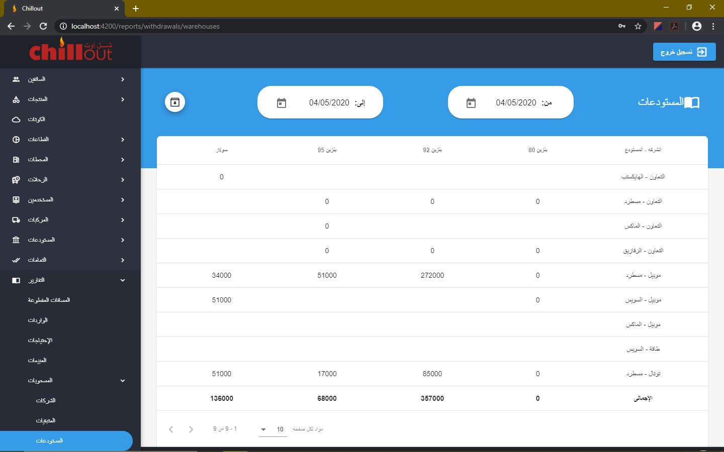

# **Important Notes:**

1. If you want to make a backup from the database (like the end of month):
   1. Open "**Task manager**" by holding CTRL + SHIFT + ESC
   2. Go to the "**Services**" page, search for "**MongoDB**"
   3. Right-click on it and stop it
   4. Go to the path "**C:\Program Files\MongoDB\Server\4.2\data**"
   5. Copy the content of that folder and paste it in another folder which you are going to use as a backup
   6. Open task manager by holding CTRL + SHIFT + ESC
   7. Go to the Services page, search for "**MongoDB**"
   8. Right-click on it and start it, then you can continue to use the program

**Note: If you want to restore a backup to the database, do the same steps except that step "e" has to be inverted**

1. Don't run the program again while the servers are already running and make sure that the 2 servers are running while you use the program